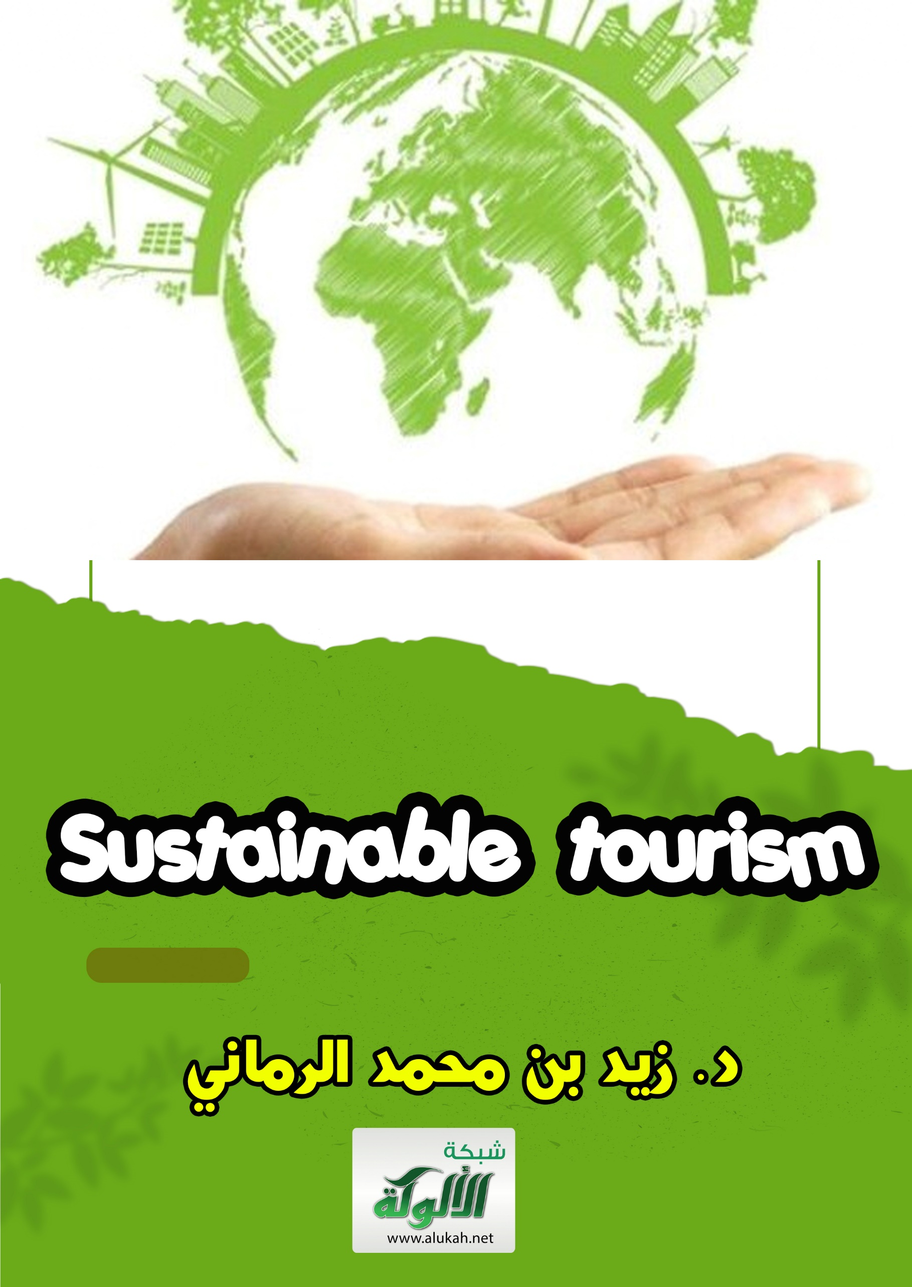
Sustainable tourism
Entrance:
The past decade has registered international interest in sustainable tourism and its protection, especially in recent years, where the issues of management, protection and development of tourism resources and facilities have been a priority in the policies and areas of cooperation of many countries.
At present, the Kingdom of Saudi Arabia is witnessing a cultural, scientific and social consciousness, which gives tourism resources great importance in the protection and preservation of them, so that this trend has become a direct impact on the thinking and lifestyle among its citizens.
It is an orientation consistent with the cultural heritage, which is sought by the Kingdom's national development plans, as it pioneered the inclusion of the principles of tourism awareness and its components.
Here it is advisable to mention some important facts on the subject, including:
1- The Islamic Sharia, through the Holy Quran and the Prophet's Sunnah, has developed a comprehensive conception of the tourism environment that includes humans, animals, plants, inanimate objects, water and air.
2- Islamic law has established the principle of bridging pretexts to corruption of any kind, in order to restrict dealing with the tourism environment, in a way that prevents it from being corrupted during the bad conduct of permits or rights, as well as transgression and aggression, which has a great impact on documenting the interests of the nation materially and morally, including tourism resources.
3- The protection of tourism resources in Islamic law is a trust and responsibility required by faith and required by the doctrine of discord in the land.

Basic Concepts:
First: The concept of tourism
According to the global concept of tourism, there are three types of tourism: 1- Domestic tourism includes the movement of citizens within the political borders of a particular country and is practiced by tourists who are residents of that country who are citizens or residents of that country. 2. Inbound Tourism means the movement of a non-citizen traveler in a country other than his or her own country (receiving country). 3- Outbound Tourism means the movement of a citizen to a country other than his own. Here we point out that the most important and attractive type of tourism for foreign exchange for the Queen is spiritual tourism or religious tourism, if the name is correct, represented by the annual visit of Muslims to the Kingdom to the holy sites for the purpose of Hajj and Umrah. Thus, tourism investment is defined as investment in one of the areas covered by the tourism sector. These areas include primary tourism facilities and support tourism services.
Second: The concept of sustainability:
A principle that economic growth and development must be established and maintained within the limits of the interrelationships between people and their actions and between the biosphere and the years that govern it.
Sustainability is a principle that means achieving a reasonable level of prosperity and security for all members of society among developing countries, and is therefore fundamental to protecting the ecological balance and preserving the elements of tourism.
Legitimate and social determinants of sustainable tourism: It is not feared that the Kingdom has all the requirements for the success of the establishment of a developed tourist market, and here I briefly alluded to the most prominent legal, economic and social determinants of tourism in the Kingdom of Saudi Arabia, through the following: The Kingdom is characterized by a unique peculiarity, which is that it is the cradle of the Islamic message, the home of the holy places, and the destination of Hajj, Umrah and visit for more than a quarter of the population of the earth, or about 1.5 billion Muslims, which makes it in a position that no one competes with in the field of developing a tourist market Huge based on the optimal utilization of this unique advantage in building a tourism sector characterized by its high competitiveness to occupy advanced positions within the global tourism market.
The presence of Islamic historical monuments not available anywhere else in the world, provides tourism in the Kingdom with a major component of tourist attractions. The Kingdom's tourism sector represents a vital renewable source that can contribute effectively to the diversification of the structure of the economy and sources of national income. The tourism sector in the Kingdom contributes to the development of rural and desert areas and raising the standard of living of their inhabitants, which in turn leads to reducing migration to major cities and the resulting developmental imbalance. The tourism sector is one of the most important sources of employment at the local level. The development of the tourism sector leads to simultaneous growth and development of basic equipment. Investment in tourism expands the investment opportunities available to various sectors such as the contracting sector, industry and tourism-related services.
The Kingdom is characterized by its tourist areas in Mecca, Medina, Jeddah, Taif, Abha, Al-Baha and Asir with the availability of multiple and integrated tourist patterns such as maritime, mountain, sandy, health, cultural and environmental tourism. Educational and social dimensions of sustainable tourism:
The continuation of each society requires solidarity and cohesion among its members, and the existence of a common set of values. Education is one of the tools that help him to continue and inherit values through its role in the science of socialization.
As the French sociologist Émile d'Or Chaim puts it, the human being that education makes up is not necessarily the model human being, but the one that society wants.
Hence, education develops a spirit of commitment among members of society, equips them with the necessary capabilities to fulfill the roles expected of them, and instills a culture appropriate to the existing social construction.
Hence Talcott Parsons identified the social functions of the school as educating younger generations on the values prevailing in society, and that it acts as a channel through which human capital is distributed to different professions.
It is no secret that socialization means that the individual imbibe rates the values, ideas and norms prevailing in society, without which the adaptation of the individual to his society becomes difficult.
According to proponents of functional constructivist analysis, education selects and selects individuals according to their abilities and talents, since one of the functions of education is selection, and that the structures of the educational system can be understood in the light of selection processes.
According to the functional perspective, the selection process links the educational system to the needs of the economy and the development plan, and provides the economy with the skills and expertise it requires for further development and expansion.
It follows that there is a close relationship between the size of the educational system and the common disciplines of a particular stage, economic needs and development priorities.
On the other hand, through equivalence within the school, the mechanisms of status shift from family to school and the possibilities for achieving social mobility through the decline of inherited status and the acquisition of a new acquired status increases.
One of the most prominent theories of the functional constructivist trend in the study of education is the theory of human capital, where the proponents of this theory emphasize the return of the educational process and that spending on education is a productive investment expenditure and not just a consumer service expenditure.
Education is an economic investment of the most important element of production, namely the human element, and the development of human capital through an educational system becomes a major factor in development efforts and an important element of investment to prepare the manpower necessary to achieve development goals.
The role of education in the development process in this context is defined as follows:
1- Education equips individuals with the qualities, skills and experience necessary for economic development.
2- One of the basic functions of the educational system is to reveal the potential among the members of society and to work on their development and investment.
3- Education instills customs and values that contribute to sustainable development.
Hence, specialists in the field of sustainable tourism and the marketing of its services have focused on the issue of the specifications that should be available in workers in this field, and many specialists have unanimously agreed on the need to have two types of characteristics:
First: Personal characteristics: in the sense that these characteristics are the ones that a person carries in all his cases without cost, and the most prominent of them: good manners, appearance, calmness, tact in speech, the ability to adapt to others, the ability to act in different situations, the ability to persuade and the ability to deal well with the tourist.
Second: Acquired characteristics, which may not be available in the tourism service provider, but can be acquired through education, training and practice, the most prominent of which are:
Provide information on tourism, English language proficiency, specialization in service marketing, and educational qualification.
In this regard, one of the researchers conducted an exploratory study on "The role of human elements in the marketing of tourism services", and concluded that the most important qualities that should be available to workers in the field of sustainable tourism and marketing of its services is to be a marketing man and a good looking service provider, where 60% of the members of the study sample answered this, followed by tact order in speech, where 55% of the sample members indicated this, then calm and patience on the tourist and the ability to act in situations Critical at 54%, and finally, both English language proficiency and availability of tourist information came in last place, with 49% of respondents indicating this.
Thus, it can be said that there should be an educational and educational capacity, self-skills, training and development capacity to carry out work in the area of sustainable tourism and the commercialization of its services
Economic aspects of sustainable tourism:
Nowadays tourism economics occupies a prominent place in contemporary studies and has even become an independent branch of these studies. The economic aspect of tourism is often the focus of attention on the various activities of tourism.
Tourism, which has multiple effects on the economy, ranges from maximizing economic growth, incomes, foreign exchange earnings and employment to improving the economic structure.
The importance of the economic aspects of the tourism sector has emerged after this sector, especially during the second half of the last century, became one of the important components of the economic structure in many countries, and after tourism became more than 6% of the global output.
Tourism activity is mostly seasonal, and there are factors that lead to seasonality, the most important of which is the concentration of school holidays and vacations in a particular season, and climatic and geographical factors call for this phenomenon.
It is clear that it is vacation tourism, which represents a great deal of tourist activity, that supports this phenomenon.
Moreover, the tourism sector has different effects on economic development through its effects on the balance of payments, employment generation, improvement of infrastructure, multiplier effects of tourism spending, as well as structural impacts.

He is not afraid, which has a negative or positive side of these effects, as he does not expect the positive of these effects absolutely.
Dr. Nabil El-Roubi, former Dean of the Faculty of Tourism at Alexandria University, says in his book "The Economics of Tourism": "It is considered a tourist expenditure, every expenditure that takes place within the host country of those who are considered tourists. Tourism spending is the expenditure made by tourists on various tourist and non-tourist goods and services during their stay in the host country.
In order to facilitate comparison from time to time and from one country to another, tourism economics writers almost unanimously divide the elements of tourism spending into four main groups used in different tourist areas, namely accommodation, food and drink, internal transportation, and other purchases.
Several scientific studies on the distribution of tourism expenditure have shown that the share of the components of tourism expenditure appears to be as follows:
- Accommodation 45%.
- Food and drink20%.
- Internal transfer 15%.
- Purchases 10%.- Entertainment and entertainment 5%.
- Other activities 5%.
Following up on the applied studies prepared in various tourist areas, some observations appeared on the employment generated in the tourism sector, including:
1-Tourism spending leads to an increase in income as employment increases in society.
2- The effects of spending on labor are affected by the quality of tourism activity.
3- A great deal of employment in the tourism sector is seasonal.
4- Seasonality in the tourism sector reflects many effects on the economic and social aspects, especially the issue of unemployed work energy in non-seasonal periods.
As for tourism training, it has its origins and dimensions, including, for example:
(A ) Training is not a program that begins and then ends in a certain period, but is an ongoing process.
(b) Training includes all employees in tourist establishments.
(c) Training requires certain elements for its success, such as:
- A suitable place for training.
- Competent trainers with the ability to transfer information.
- Training tools suitable for different disciplines.
- A body that develops specific training programs.
Thus, working in the tourism sector requires that the individual be at a high professional and behavioral level with proficiency in one or more foreign languages.
The tourism industry also requires an individual to love and be convinced of the work they perform, have an abundance of public information and culture with self-confidence.
Also, the tourism worker should be a collaborator working in harmony with his colleagues. Tourism is the work of an integrated team, as the work of each individual complements the work of the other, just like the sports team.
It is clear from the above that manpower plays a crucial role in influencing the growth and development of activity in the tourism sector.
In recent years, there has been interest in preparing the workforce in tourism activity in order to improve and upgrade the service.
He is not afraid that the tourism market is usually exposed to the problem of lack of trained and specialized labor, due to the expansion of tourism projects and the migration of many skilled elements to neighboring countries, as well as the reluctance to work in hotels in general, and the lack of personal conviction in this sector from some young people.
Therefore, employment planning in the tourism sector at different levels (professional, specialized, supervisory, senior management...) is an essential step in the success of the tourism development plan.
It is essential that tourism training has a comprehensive view supported by technical, human and financial capabilities to ensure the success of the training process, in order to prepare trained workers capable of improving the level of performance in the tourism community.
Here, there is an urgent need for a comprehensive tourism training plan to be implemented at various levels.
Media roles to promote sustainable tourism:
Tourism has become a major industry on a global scale and is expected to grow continuously. The number of international tourists has tripled over the past two decades and international tourism revenues have risen from almost $22 billion to about $300 billion in the nineties.
In the view of some economists, international tourism is an important means of contributing to the economic growth of developing countries.

Although studies conducted in the past two decades have proven that the cost of necessary infrastructure and supplies necessary for international tourism has been very high in terms of foreign exchange.
It should be emphasized that it is not tourism that leads to development, but the general development of a particular country that makes tourism profitable. Therefore, international tourism earnings are not a true indicator of real tourism income.
However, tourism can have both positive and negative effects on the human environment.
Therefore, it can be said that one of the most important tasks entrusted to the media in the field of spreading tourism awareness in society is the following:
First: Intensifying awareness programs through guidance leaflets on domestic tourism awareness.
Second: Directing information programs for domestic tourist attractions.
Third: Stimulate measures to preserve the physical features of sustainable ecotourism.
Fourth: Care for historical sites and monuments and wildlife.
Fifth: Allocating press and radio spaces for national tourism education and spreading tourism awareness.
Recreation and sustainable tourism are usually the primary objectives of the establishment and development of national parks and other types of protected areas. Scenic spots have become major attractions and form the basis of what is known as ecotourism.
Therefore, tourism media goes beyond just covering tourism festivals.

This is evidenced by the fact that ecotourism yields direct financial benefits that outweigh the cost of maintaining and developing Riyadh, as well as digging employment and rural development in neighboring areas.
Moreover, historical and cultural heritage determines the attractiveness of a particular country to tourists and encourages Governments to protect it and preserve its features.
Therefore, many States are making great efforts to provide regular protection for cities, villages and archaeological areas of aesthetic heritage, especially those of historical and artistic importance.
On the other hand, the media still presents incomplete images of inland tourist areas.
Although in all our cities and provinces we have many tourist attractions and archaeological areas, those fragrant with the fragrance of history.
The roles expected of all print and broadcast media are very large.
Here, there is an urgent need for a comprehensive national media plan to raise tourism awareness and disseminate tourism media in society, in order to promote sustainable tourism.
The Future of Sustainable Tourism:
There are a number of indicators that reflect the reality of tourism activity in the Kingdom, in 1999 the revenues of this activity amounted to about $ 1.8 billion, representing about 1% of the GDP for the same year.
The number of workers in this sector during the same year reached about 300,000 workers, constituting 4.9% of the total number of workers in the Kingdom.
Capital invested in tourism activities reached US$1.13 billion during that year.

Despite this, the tourism sector in the Kingdom is one of the promising sectors in the national economy, and there are still many tourism potentials that await the contributions of Saudi investors in order to support the tourism development process.
It is worth mentioning that the success in attracting Saudi tourists to spend their holidays in the Kingdom will lead to recycling a lot of money within the geographical borders of the Kingdom and reduce the leakage of national income
With regard to the movement of tourists from outside the Kingdom, the number of pilgrims and Umrah performers coming to the Kingdom has witnessed developments associated with the rules governing Hajj and Umrah, as the number of pilgrims and Umrah performers has evolved from 911 thousand pilgrims in 1391 AH to more than three million pilgrims in 1420 AH, and this number is expected to double during the next few years, in light of the application of the Umrah system currently in force.
Hopes are pinned, God willing, on the new regulations of Umrah so that they give the opportunity to attract Umrah pilgrims within political programs that double the achieved incomes, and ensure that tourists do not lag behind and return to their country at the end of the trip.
Therefore, Saudi specialists have predicted that the investments needed by the Saudi tourism market will reach about 200 billion riyals. Saudi Arabia is currently qualified to accommodate at least 30 million visitors and tourists annually.
It is also expected that the Kingdom will acquire a larger share of global and regional tourism during the next few years, due to the Kingdom's multiple tourism potentials and the increasing interest of the tourism sector by the concerned authorities in the country, in addition to the application of the new Umrah system, which opens the way to visit the Holy Land throughout the year, and allows those coming on Hajj and Umrah visas to visit the rest of the Kingdom's regions.
Therefore, indicators confirm the possibility of developing demand for tourism in the Kingdom in the coming years under the new regulations, especially with the incentives and facilities that accompanied the establishment of the Supreme Commission for Tourism.

Recommendations:
1) The composition of those working in the field of tourism services should be reviewed and try to involve specialized and trained competencies.
2) It is necessary to focus on training and development to work in the field of tourism services and focus on specialized programs in this field.
3) Various media should be involved in disseminating business ethics in the field of tourism services, as they achieve growth in the field of sustainable tourism development.
4) It is preferable to focus on the characteristics required to be available to workers in the field of tourism, the most important of which are: education, training, skills and the arts of dealing with others.
5) It is desirable to educate community members about the challenges facing the tourism sector, so that the best results can be achieved from investing in tourism activity to achieve the principle of sustainability.
6) Qualified Saudi youth should be provided and trained on how to work in the tourism sector and its various facilities.
7) It is necessary to conduct more studies, research and statistical permits in the various fields of tourism to determine the quality of obstacles and how to address them, and to search for the best ingredients necessary for sustainable tourism.
8) We recommend the establishment of a tourist services office that performs the following tasks:
a) Preparing an updated database on tourist places.
b) Preparing a database of tourism economic information to serve investors.
c) Dissemination of available tourism investment opportunities.
d) Advertising national festivals and events as tourist attractions.
e) Supervise the level of performance of tourism services.
9) We call for travel and tourism companies to prepare a variety of tourism programs outside the Kingdom linked between Hajj and Umrah and visiting tourist facilities and between various types of sustainable tourism.
10- We recommend studying the possibility of establishing a fund to finance sustainable tourism development similar to other development funds, provided that this is done within the system of conditions necessary to achieve sustainable growth of tourism.
Sources and references
1- Economic Studies Dr. Zaid Al-Rommany, Dar Tuwaiq for Publishing, Riyadh 1424 AH, pp. 39-60.

2- The tourism market and the future prospects for tourism in the Kingdom, a working paper of the Chamber of Commerce and Industry in Jeddah, presented to the fourteenth annual meeting of the Saudi Economic Association during the period 15-17 Safar 1423 AH, pp. 4-8.

3- The Future of the World Order and the Experiences of Educational Development, Dr. Saad Eddin Ibrahim, Arab Thought Forum, Amman, 1989, pp. 42-46.

4- The role of human elements in marketing tourism services, d. Habib Allah Muhammad Al-Turkistani, a working paper presented to the fourth annual meeting of the Saudi Economic Association, during the period 15-17 Safar 1423 AH, pp. 12-17.

5- Tourism Economics, Dr. Nabil El-Rouby, University Culture Foundation, Alexandria, 1998, pp. 24-33.

6- Contemporary Economic Language, Dr. Zaid Al-Rumani, Al-Yamamah Press Foundation, Riyadh, 1420 AH, pp. 143-145.

7- Economic windows, d. Zaid Al-Rumani, Dar Tuwaiq Publishing, Riyadh 1422 AH, pp. 40-44.

8- Theoretical Islamic Media, Dr. Saeed Ismail Chini, King Fahd National Library, Riyadh, 1417 AH, pp. 168-177.

9- Tourism Investment in the Kingdom of Saudi Arabia, a working paper of the Supreme Commission for Tourism presented to the fourteenth annual meeting of the Saudi Economic Association, during the period 15-17 Safar 1423 AH, pp. 9-11.

10- Participation between the public and private sectors in the development of tourism and investment in the Kingdom, a working paper of the Department of Research and Economic Studies at the Council of Saudi Chambers of Commerce and Industry, presented to the fourteenth annual meeting of the Saudi Economic Association, during the period 15-17 Safar 1423 AH, pp. 4-7.

